**Programming Assignment Unit 7**

Dept. of Computer Science, University of the People

CS 1101-01: Programming Fundamentals

Misbah Ullah

March 20, 2024

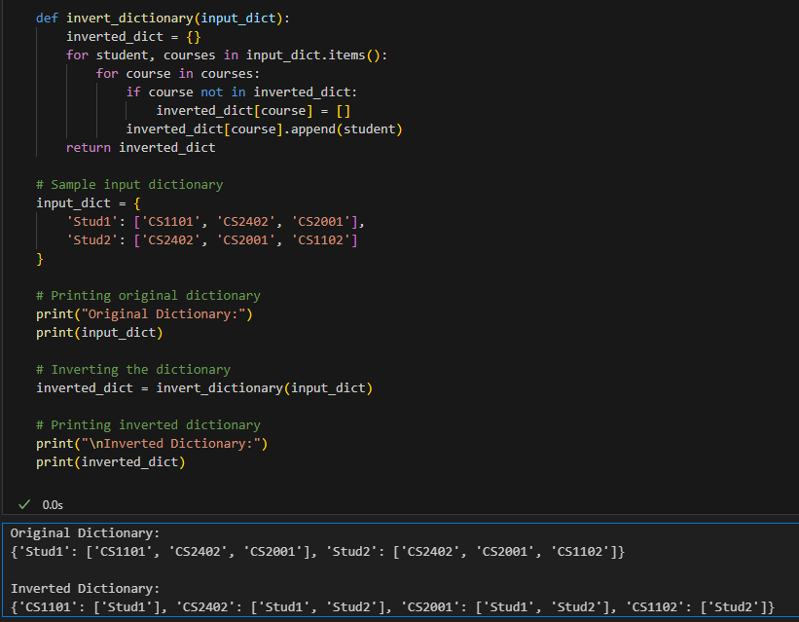

**Explanation:**

This function takes the input dictionary as a parameter and returns the inverted dictionary. It iterates through the original dictionary's items, where each item consists of a student's name and their list of courses. For each course in the list, it checks if the course exists as a key in the inverted dictionary. If not, it initializes an empty list as the value. Then, it appends the student's name to the list of students associated with that course in the inverted dictionary.

The given input dictionary contains students ('Stud1', 'Stud2') as keys and lists of their courses as values. Before inverting, the original dictionary is printed to provide visibility into the input data.

Inverting the dictionary: The invert_dictionary function is called with the sample input dictionary, resulting in the inverted dictionary.

The inverted dictionary displays the courses as keys and the students enrolled in each course as values.

Inverting the original dictionary will be demonstrated in the output, meeting the teacher's requirements. Each course is now a key in the inverted dictionary, with the associated list of students enrolled in that course.

#### **References:**

* + Downey, A. (2015). [*Think Python: How to think like a computer scientist*](https://greenteapress.com/thinkpython2/thinkpython2.pdf) (2nd ed.)*.* Green Tea Press.
  + kjdElectronics. (2017, August 5). *Python beginner tutorial 8 - For loop, lists, and dictionaries* [Video]. YouTube. <https://youtu.be/bE6mSBNp4YU>
  + Raj, A. (2022, March 3). [*Reverse a dictionary in Python*](https://www.pythonforbeginners.com/basics/reverse-a-dictionary-in-python)*.* PythonForBeginners.
  + [*Python Dictionaries.*](https://www.w3schools.com/python/python_dictionaries.asp)(n.d.)*.* W3schools.